Lab # 02
Name: Rafia Fiaz
Reg No: 2023-BSE-051
Class & Section: BSE 5-B
Submitted To: Sir Shoaib

Task 1:
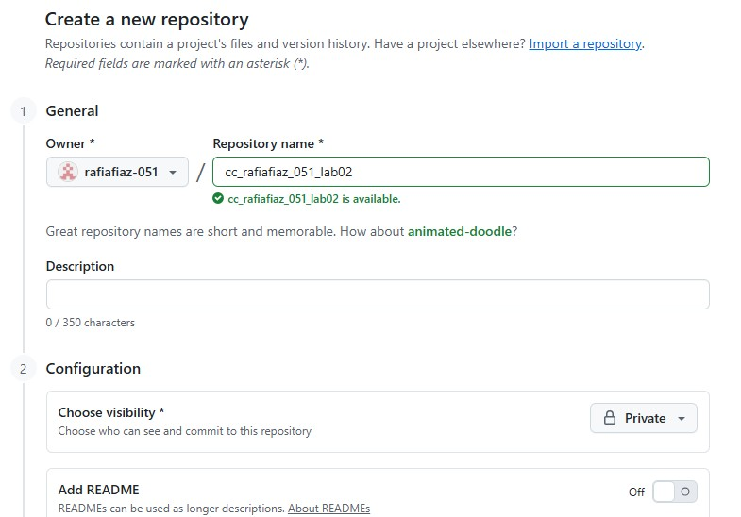

Task 2:
- Generate a new SSH key using PowerShell:
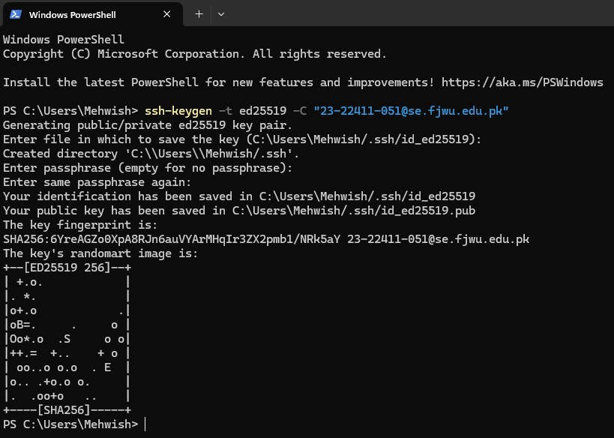

- Add your SSH public key to GitHub (Settings > SSH and GPG keys):
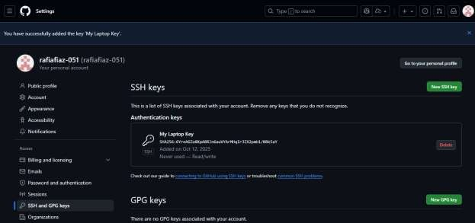
- Clone your Lab2 repo using SSH:
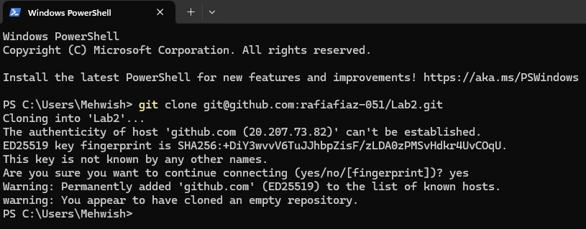
Task 3:
- Set up your Git identity (this ensures all commits are linked to you):
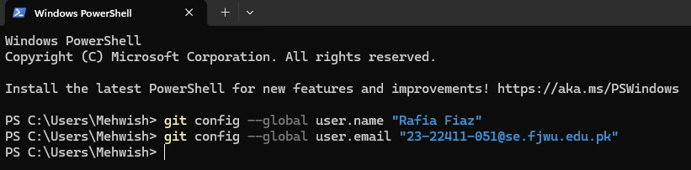
- Verify your configuration:
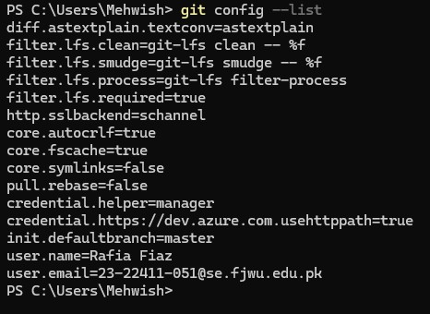
Task 4:
Explore the .git Folder:
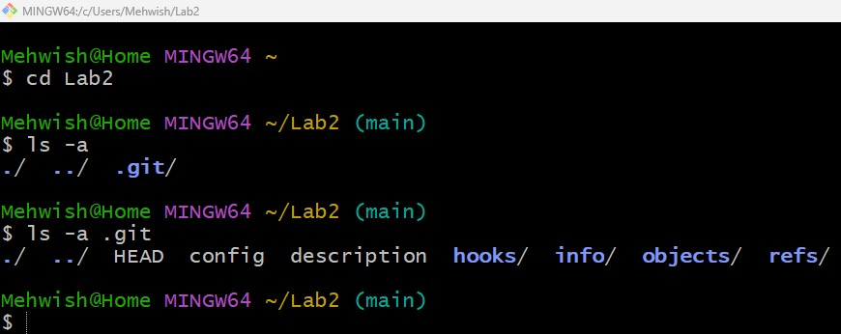
Task 5:
- Delete the existing .git folder from your cloned repo using Git Bash:
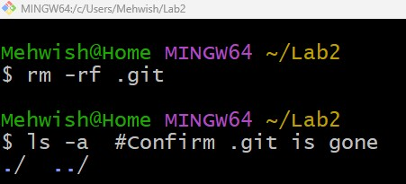

- Re-initialize the local git repository:
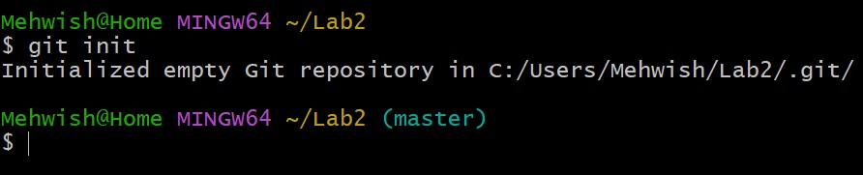
- Add a file named README.md and commit it:
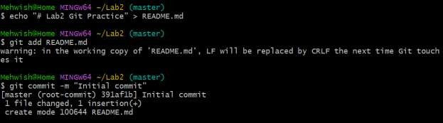
- Connect your local repo to GitHub and push:
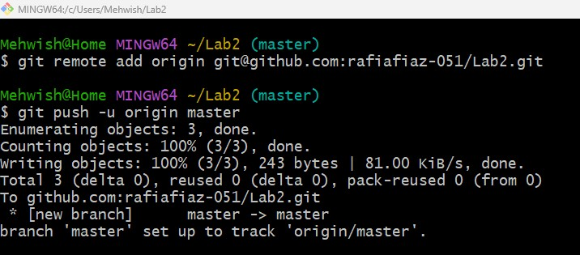
Task 6:
- Create a new file notes.txt and write a note. Check Status:
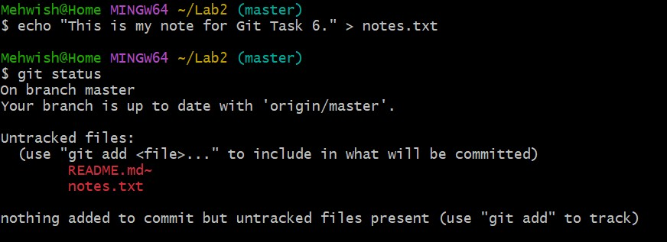
- Stage and commit:
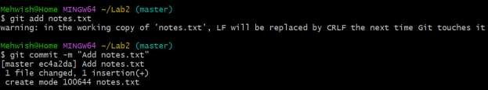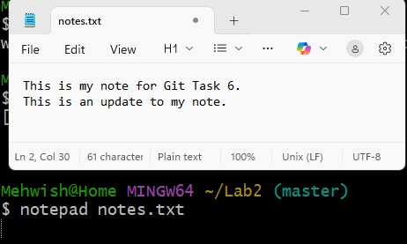

- Edit notes.txt and repeat status/commit steps:
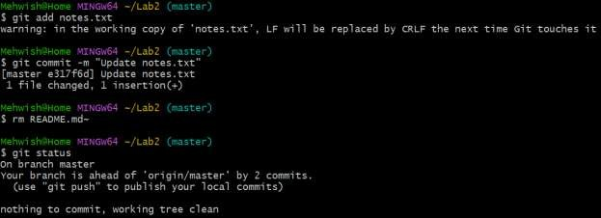
Task 7:
- On GitHub (web interface), create a branch named bugfix/user-auth-error.
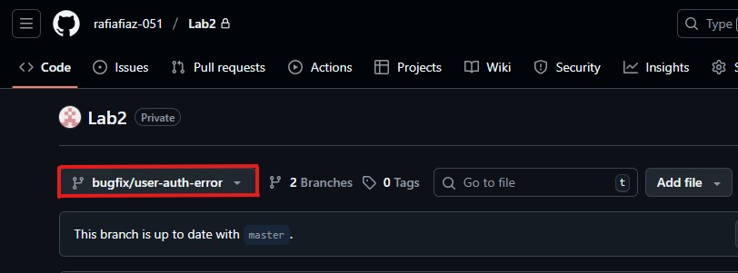
- Pull the branch to your local repository to sync.
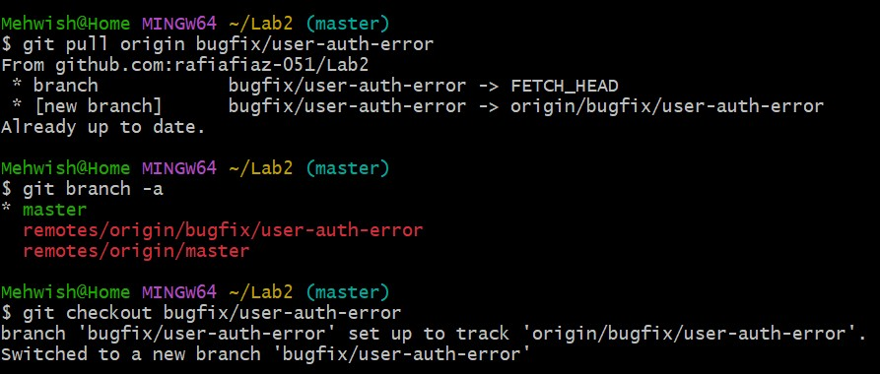
Task 8:
Create a branch named feature/db-connection using Git Bash & Push the branch to the remote repository.
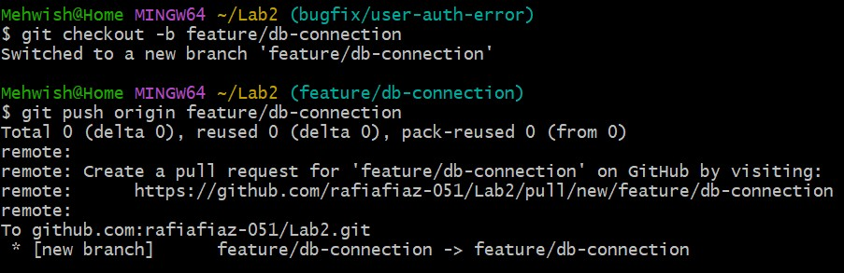
Task 9:
- Create and switch to a new branch:
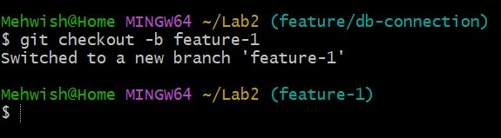
- Modify main.py:
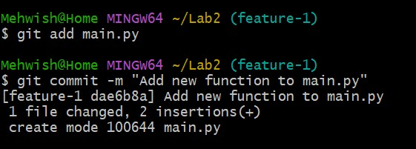
- Switch back to main and merge:
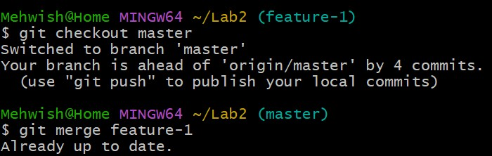
- Push all branches:
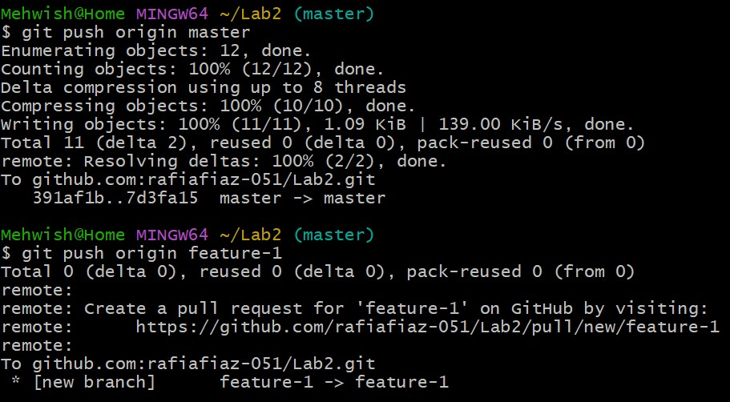
Task 10:
- On GitHub, create a Pull Request from the branch feature/db-connection to master.
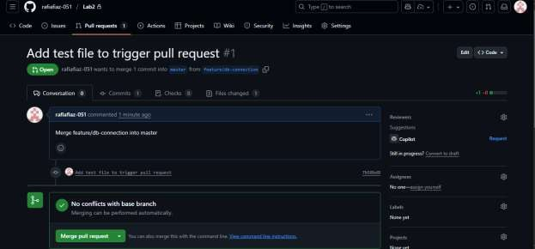

- Review the Pull Request and merge it using the GitHub GUI.

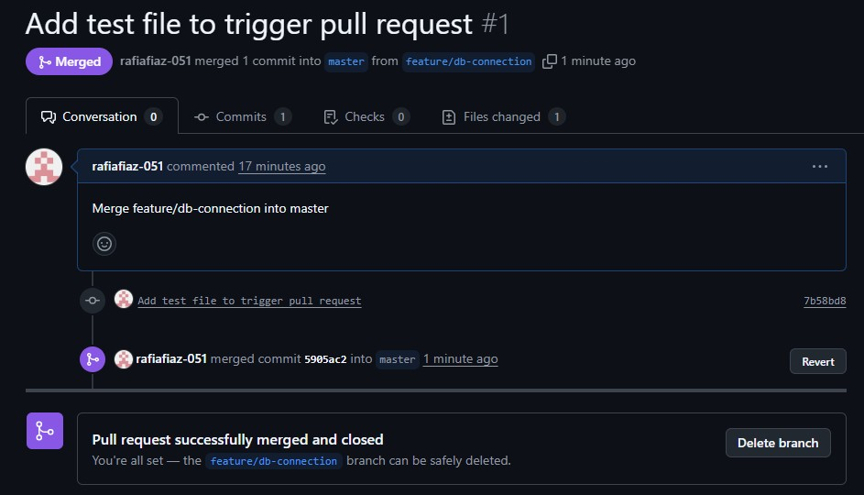
- After merging, delete the feature/db-connection branch using the GitHub GUI.
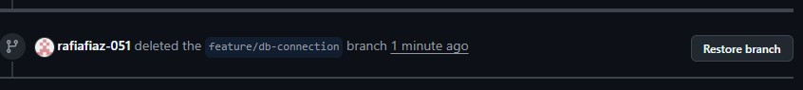

Task 11:
- Create the following branches to simulate a professional branching strategy:
o Develop o Staging o Feature/* o Bugfix/*

- Example workflow:
  - Developers work on feature/* and bugfix/* branches. o Merge into develop after completion. o develop is merged into staging for testing. o Finally, staging is merged into main (production).

- Document the workflow with screenshots: o Branch list (branch_strategy.png).
  - Merges into develop and staging (branch_merges.png) o Final merge into main (final_merge.png)

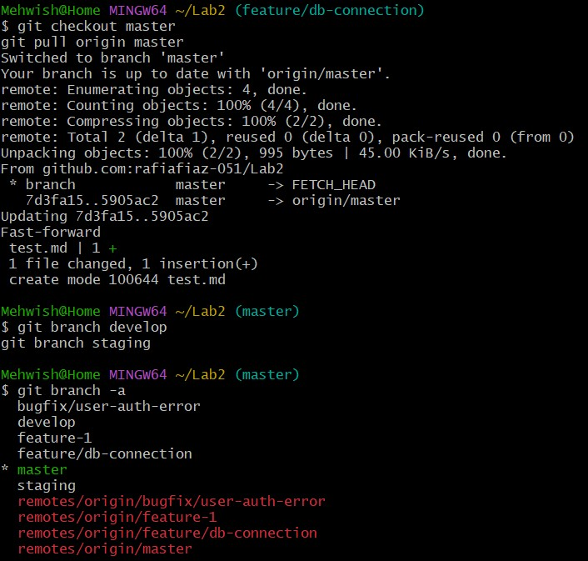
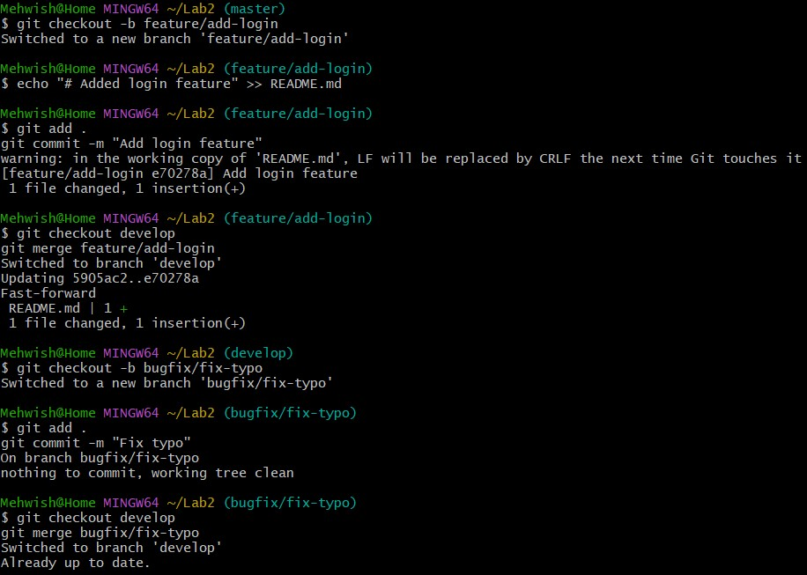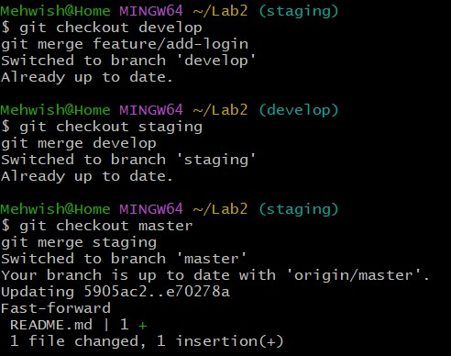

Bonus Task:
- Create a branch collab.
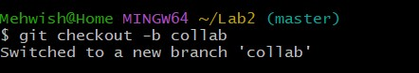
- Add a collaborator on your GitHub repository.
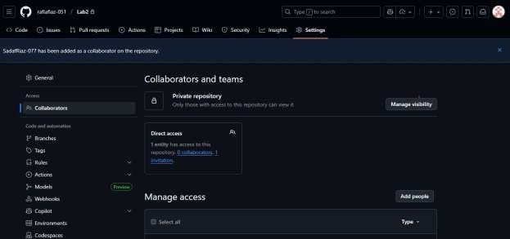
- Both users:
o Pull latest changes. o Add their name and fun fact to notes.txt. o Commit and push to the collab branch.
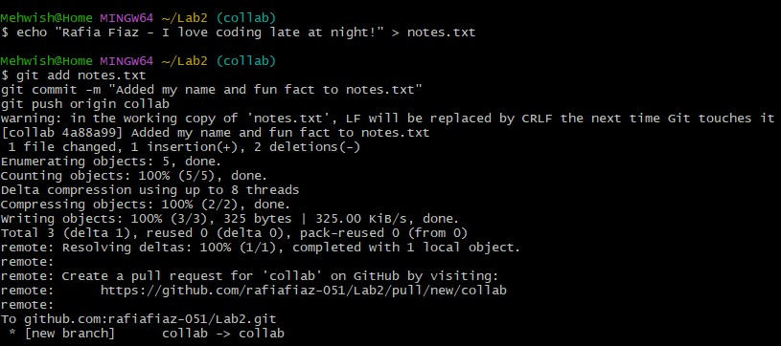
- Merge collab into main and push.
git checkout main git merge collab git push origin main
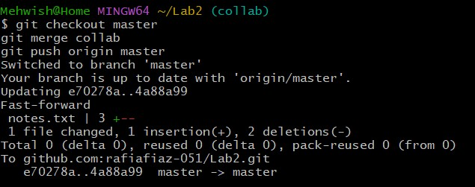
Task 12:
- Create a Pull Request (PR) / Merge Request (MR):
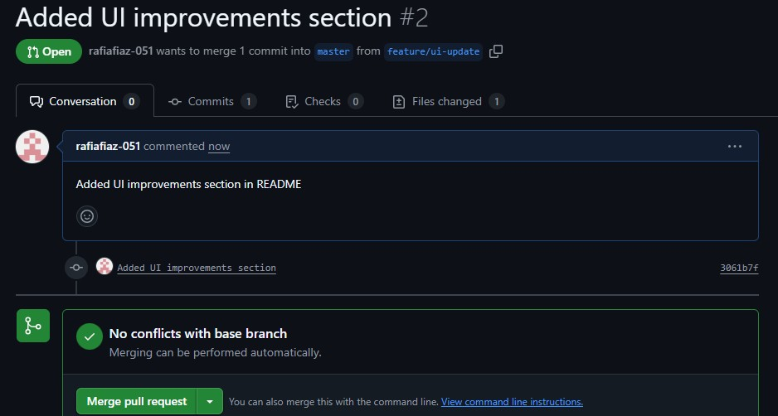

- Assign a reviewer (teammate or second account):
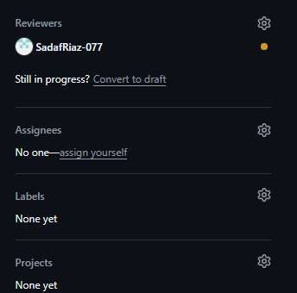
- Reviewer Actions :
  - Approve the PR
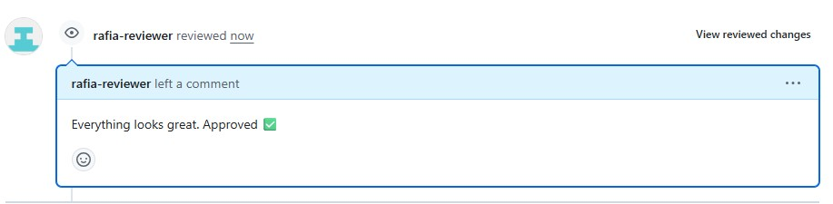
  - Request Changes
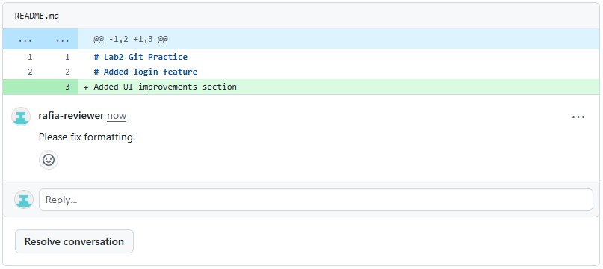
- Author Actions:

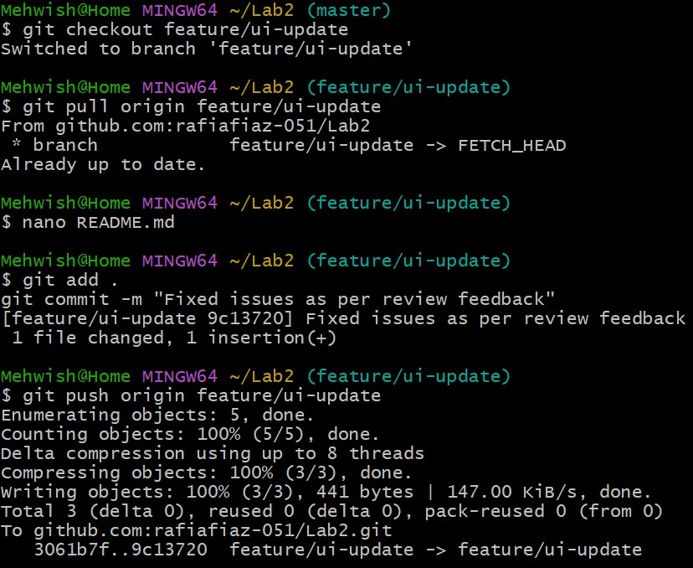

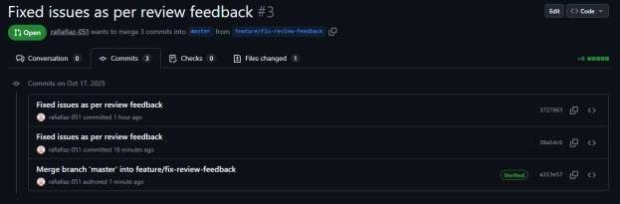
- Merge the PR:
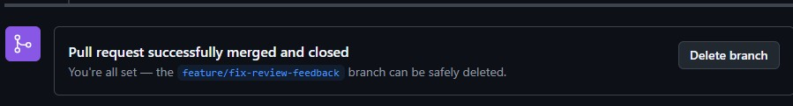
- Branch Handling After Merge:
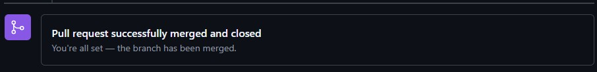

Task 13:
- Delete Remote Branch After Merge:
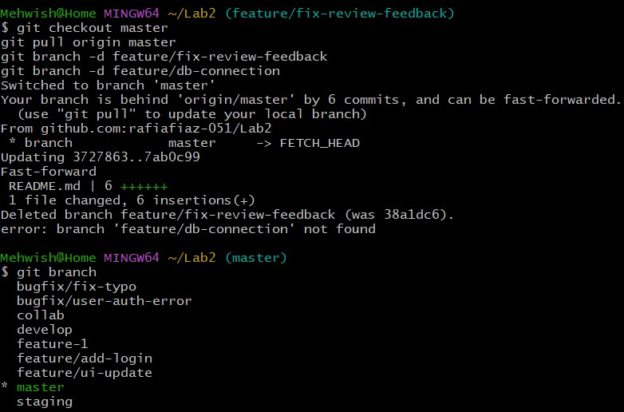
- Update Local Repository
